1. Database Design

✔ Why Relational Database Model?
A relational database is suitable because:
- Stores data in structured tables (rows & columns)
- Reduces data duplication
- Maintains data integrity using keys (PK & FK)
- Allows easy retrieval using SQL queries and JOINs
- Supports relationships between entities

Main Entities & Relationships

Entities:
- Patients
- Doctors
- Appointments

Relationships:
- One Patient → Many Appointments (1:N)
- One Doctor → Many Appointments (1:N)
✔ ER Diagram Structure
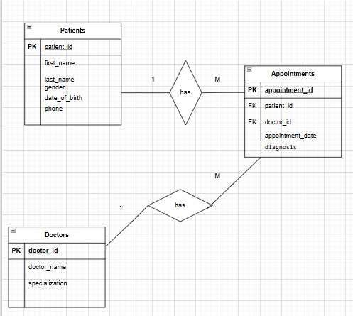

🧩 2. Normalization (Up to 3NF)

Unnormalized Table Problem
If everything is in one table:
- Data duplication (patient repeated many times)
- Update anomalies
- Difficult maintenance
- Inconsistent data

✔ First Normal Form (1NF)
- Remove repeating groups
- Ensure atomic values

✔ Second Normal Form (2NF)
- Remove partial dependency
- Separate:
  - Patients
  - Doctors
  - Appointments

✔ Third Normal Form (3NF)
- Remove transitive dependency
- Ensure:
  - All non-key attributes depend only on the primary key
✅ Final Tables:
- Patients
- Doctors
- Appointments

✅ Project Summary
- Organizes hospital data efficiently
- Tracks patient medical history
- Improves data accuracy
- Enables fast report generation

-- 1. Create Database
CREATE DATABASE hospital_db;
USE hospital_db;

-- 2. Create Tables
CREATE TABLE Patients (
patient_id INT PRIMARY KEY,
first_name VARCHAR(50),
last_name VARCHAR(50),
gender VARCHAR(10),
date_of_birth DATE,
phone VARCHAR(15)
);
CREATE TABLE Doctors (
doctor_id INT PRIMARY KEY,
doctor_name VARCHAR(100),
specialization VARCHAR(100)
);
CREATE TABLE Appointments (
appointment_id INT PRIMARY KEY,
patient_id INT,
doctor_id INT,
appointment_date DATE,
diagnosis VARCHAR(200),

FOREIGN KEY (patient_id) REFERENCES Patients(patient_id),
FOREIGN KEY (doctor_id) REFERENCES Doctors(doctor_id)
);
-- 3. Insert Sample Data
INSERT INTO Patients VALUES
(1, 'Alice', 'Uwimana', 'Female', '2000-05-10', '0788001111'),
(2, 'Jean', 'Ndayishimiye', 'Male', '1998-09-15', '0788002222'),
(3, 'Grace', 'Mukamana', 'Female', '2002-01-20', '0788003333');

INSERT INTO Doctors VALUES
(1, 'Dr. Mugisha', 'General Medicine'),
(2, 'Dr. Uwase', 'Pediatrics'),
(3, 'Dr. Habimana', 'Surgery');

INSERT INTO Appointments VALUES
(1, 1, 1, '2024-01-10', 'Malaria'),
(2, 2, 2, '2024-01-12', 'Flu'),
(3, 3, 1, '2024-01-15', 'Stomach pain');

-- 4. Retrieve Patient Medical History
SELECT
Patients.first_name,
Patients.last_name,
Appointments.appointment_date,
Appointments.diagnosis
FROM Appointments
JOIN Patients ON Appointments.patient_id = Patients.patient_id;

-- 5. List Patients Who Visited on a Specific Date
SELECT first_name, last_name
FROM Patients
JOIN Appointments
ON Patients.patient_id = Appointments.patient_id
WHERE appointment_date = '2024-01-10';

-- 6. Update Patient Information
UPDATE Patients
SET phone = '0788999999'
WHERE patient_id = 1;

-- 7. Delete a Patient Record
DELETE FROM Patients
WHERE patient_id = 3;

-- 8. Generate Patient Reports Using JOINs
SELECT
Patients.first_name,
Patients.last_name,
Doctors.doctor_name,
Doctors.specialization,
Appointments.appointment_date,
Appointments.diagnosis
FROM Appointments
JOIN Patients ON Appointments.patient_id = Patients.patient_id
JOIN Doctors ON Appointments.doctor_id = Doctors.doctor_id;

